Sandbox Exercise- Materials List

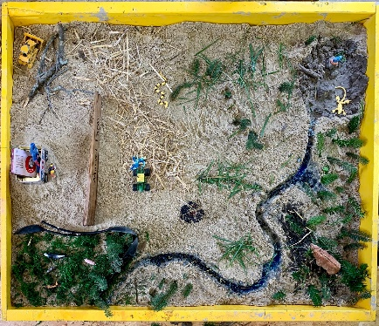
The frames for the sandbox exercise are 3’ x 4’ and constructed from 2x4 or 1x4 stock lumber.
You’ll need a frame for every 5 people, so a workshop with 20 people should have 4 frames. Each frame is laid on top of a ½” sheet of plywood or OSB.
Participants should have a variety of materials to work with to get creative and build their own wetland restoration project.

Materials can include:

- Large bins of sand
- Clay (to line waterways and wetland depressions)
- Rocks (from small pebbles to gravel)
- Leaves
- Toy farm animals and farming/construction equipment (some unexpected items like dinosaurs and sea creatures can add some fun to the activity!)
- Baling twine
- Grass clippings
- Moss
- Hay
- Wood chips
- Small branches
- Pine needles
- Straws (to build drainage structures)
- Spray bottles, hand rakes and trowels
- Wood shingles or cardstock to make a sign for the project
- Sharpie markers
- Laundry detergent or bubble bath (to be the “water” in the wetland)

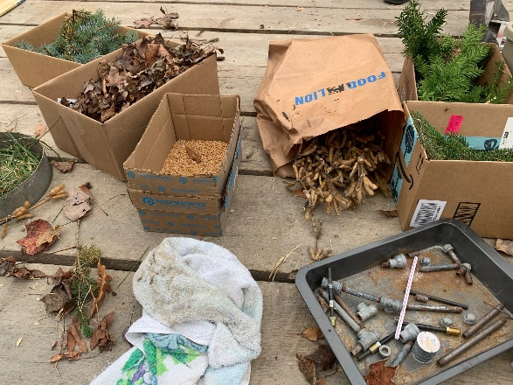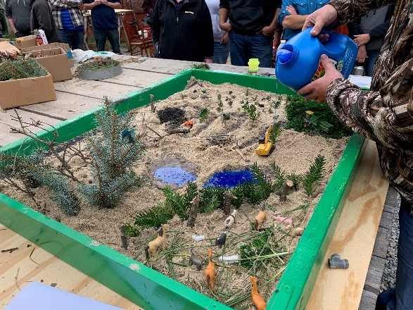
Adding “water” to test the wetland
Provide a variety of materials

At the end of the exercise, have the participants help to separate the “clean” materials from the materials that have been mixed with the laundry detergent. You’ll find that the soiled material isn’t very high in volume for disposal.

